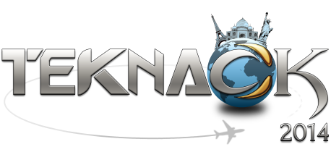
Don Bosco Institute of Technology, Mumbai is organizing Teknack – the annual online inter-college Technical festival on 15-16 February 2014. It is organized annually by the ACM DBIT Student Chapter, Kurla. This event provides a global arena, encouraging all undergraduate students to emancipate their minds and promote the technical as well as the creative genius within them, by providing them a common platform to exhibit and appraise their talents and skills. Teknack was started with a simple vision in mind – ‘Technology at your doorstep’. In this age of technology where everything is available at the click of a button, the same can be applied to college festivals. This is an online event and the internet is in the hands of every common man thus, making this event easily accessible to every college student.
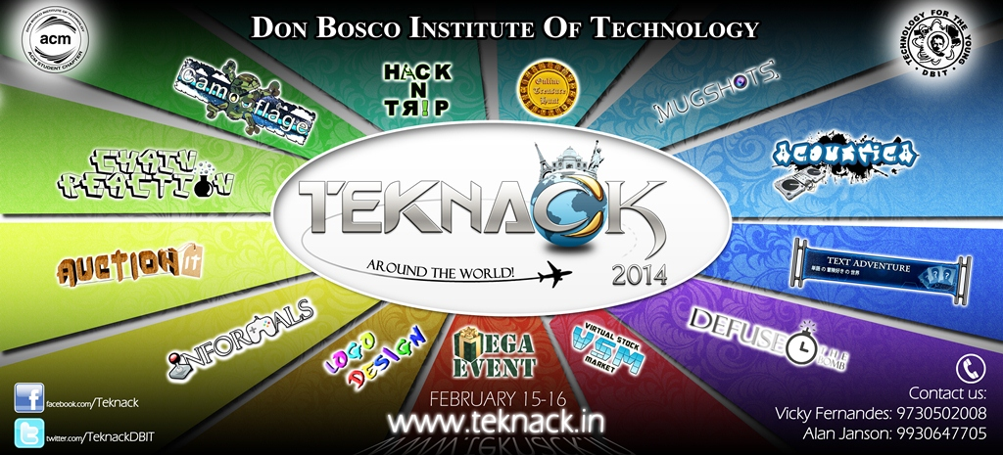
This year, Teknack comes in a different approach by making the events more fun-filled rather than more technical in order to make it suitable for students from various disciplines to participate. The theme for Teknack 2014 is “Around the world”, giving participants a virtual tour of various places in the world around us.
Teknack 2014 poster
Events:
There are 13 events which are present for the 2014 rendition of Teknack. The events are as follows:
- Auction it
- Defuse the bomb
- Camouflage
- Chain Reaction(Multiplayer Game)
- Mug shots(Photography event)
- Mega Event
- Virtual Stock Market
- Online Treasure Hunt
- Acoustica
- Hack N Trip
- Logo Designing
- Text Adventure
- Informals (HTML5 Games)

Registration fee:
The registration fee for this event is`30/-. After paying this amount, participants are eligible to play all the events in Teknack.
Prizes:
There are prizes worth `1, 00,000** that can be won in Teknack 2014.
Contact Us:
www.teknack.in
teknack.in@gmail.com
www.facebook.com/teknack

www.twitter.com/TeknackDBIT

google.com/+TeknackDBIT

For Registration and event details:
Vicky Fernandes
+91-9730502008
vickyfernandes033@gmail.com
Alan Janson
+91-9930647705

